Aim: To design a basic Flutter application layout using layout widgets such as Row, Column, Container, Expanded, and Padding.

Theory:

Q1. What is Layout?
Arrangement of widgets on screen using structured positioning rules.
- Controls alignment, spacing, and sizing of child widgets.
- Organizes UI elements into rows, columns, or stacks.
- Ensures responsive design across different screen sizes.
- Managed using layout widgets like Row and Column.

Q2. Why Layout Widgets are needed?
Widgets used to control positioning and arrangement of UI elements.
- Help create structured and readable user interfaces.
- Provide alignment and spacing between multiple widgets.
- Support responsive adjustments for various device screens.
- Allow flexible sizing using constraints and expansion rules.

Q3. Why Container is important?
A versatile widget used for styling and positioning elements.
- Allows adding padding, margin, and alignment properties.
- Supports decoration like color, border, and shadows.
- Can control width and height constraints easily.
- Combines multiple layout and styling features together.

Q4. What is a Padding widget?
Widget that adds empty space around its child widget.
- Creates spacing between child and surrounding widgets.
- Improves visual clarity and layout readability.
- Uses EdgeInsets to define specific spacing values.
- Does not affect child’s internal styling properties.

Q5. What is an Expanded widget?
Widget that expands a child to fill available space.
- Used inside Row, Column, or Flex widgets.
- Divides remaining space among multiple children.
- Supports flexible layout design for responsiveness.
- Uses flex property to control space distribution.

Q6. What is Scaffold and why is it needed?
Basic page structure widget providing standard app layout framework.
- Provides app bar, body, drawer, and floating button.
- Implements material design visual layout structure.
- Acts as base structure for every screen.
- Manages snackbars and bottom navigation bars.

Q7. Design a basic Flutter application layout using layout widgets such as Row, Column, Container, Expanded, and Padding.
Code:

import 'package:flutter/material.dart';
void main() {
runApp(const MyApp());
}
class MyApp extends StatelessWidget {
const MyApp({super.key});
@override
Widget build(BuildContext context) {
return MaterialApp(
debugShowCheckedModeBanner: false,
home: HomeScreen(),
);
}
}
class StrawHat {
final String fullName;
final String alias;
final String role;
final String age;
final String gender;
final String description;
final String image;
StrawHat({
required this.fullName,
required this.alias,
required this.role,
required this.age,
required this.gender,
required this.description,
required this.image,
});
}
class HomeScreen extends StatelessWidget {
HomeScreen({super.key});
final List<StrawHat> crew = [
StrawHat(
fullName: "Monkey D. Luffy",
alias: "Straw Hat",
role: "Captain",
age: "19",
gender: "Male",
description: "Future King of the Pirates with rubber powers.",
image: "assets/img/luffy_wanted_poster.png",
),
StrawHat(
fullName: "Roronoa Zoro",
alias: "Pirate Hunter",
role: "Swordsman",
age: "21",
gender: "Male",
description: "Master of Three-Sword Style.",
image: "assets/img/zoro_wanted_poster.png",
),
StrawHat(
fullName: "Nami",
alias: "Cat Burglar",
role: "Navigator",
age: "20",
gender: "Female",
description: "Expert navigator and weather specialist.",
image: "assets/img/nami_wanted_poster.png",
),
StrawHat(
fullName: "Usopp",
alias: "God Usopp",
role: "Sniper",
age: "19",
gender: "Male",
description: "Sharpshooter and brave warrior of the sea.",
image: "assets/img/usopp_wanted_poster.png",
),
StrawHat(
fullName: "Sanji",
alias: "Black Leg",
role: "Cook",
age: "21",
gender: "Male",
description: "Martial artist and master chef.",
image: "assets/img/sanji_wanted_poster.png",
),
StrawHat(
fullName: "Tony Tony Chopper",
alias: "Cotton Candy Lover",
role: "Doctor",
age: "17",
gender: "Male",
description: "Reindeer with human-human fruit powers.",
image: "assets/img/chopper_wanted_poster.png",
),
StrawHat(
fullName: "Nico Robin",
alias: "Devil Child",
role: "Archaeologist",
age: "30",
gender: "Female",
description: "Can sprout body parts anywhere.",
image: "assets/img/robin_wanted_poster.png",
),
StrawHat(
fullName: "Franky",
alias: "Cyborg",
role: "Shipwright",
age: "36",
gender: "Male",
description: "Super cyborg shipbuilder.",
image: "assets/img/franky_wanted_poster.png",
),
StrawHat(
fullName: "Brook",
alias: "Soul King",
role: "Musician",
age: "90",
gender: "Male",
description: "Living skeleton musician.",
image: "assets/img/brook_wanted_poster.png",
),
StrawHat(
fullName: "Jinbe",
alias: "Knight of the Sea",
role: "Helmsman",
age: "46",
gender: "Male",
description: "Former Warlord of the Sea and master of Fish-Man Karate. A loyal and honorable helmsman of the Straw Hat Pirates.",
image: "assets/img/jinbe_wanted_poster.png",
),
];
@override
Widget build(BuildContext context) {
return Scaffold(
backgroundColor: Colors.brown[200],
appBar: AppBar(
title: const Text("Straw Hat Pirates"),
centerTitle: true,
backgroundColor: Colors.red,
),
body: Padding(
padding: const EdgeInsets.all(12.0),
child: Column(
children: [
// Header Section
Container(
padding: const EdgeInsets.all(16),
decoration: BoxDecoration(
color: Colors.orange[200],
borderRadius: BorderRadius.circular(12),
),
child: const Row(
children: [
Expanded(
child: Text(
"Wanted Posters",
style: TextStyle(
fontSize: 22,
fontWeight: FontWeight.bold,
),
),
),
Icon(Icons.local_fire_department, size: 28),
],
),
),
const SizedBox(height: 16),
// Grid Section
Expanded(
child: GridView.builder(
itemCount: crew.length,
gridDelegate:
const SliverGridDelegateWithFixedCrossAxisCount(
crossAxisCount: 5, // 5 columns
crossAxisSpacing: 8,
mainAxisSpacing: 8,
),
itemBuilder: (context, index) {
final member = crew[index];
return GestureDetector(
onTap: () => showDetails(context, member),
child: Container(
decoration: BoxDecoration(
color: Colors.yellow[100],
borderRadius: BorderRadius.circular(8),
border: Border.all(color: Colors.brown, width: 2),
),
child: Column(
children: [
Expanded(
child: Image.asset(
member.image,
fit: BoxFit.cover,
),
),
Padding(
padding: const EdgeInsets.all(4.0),
child: Text(
member.alias,
style: const TextStyle(
fontSize: 12,
fontWeight: FontWeight.bold,
),
textAlign: TextAlign.center,
),
),
],
),
),
);
},
),
),
],
),
),
);
}
void showDetails(BuildContext context, StrawHat member) {
showModalBottomSheet(
context: context,
isScrollControlled: true,
builder: (context) {
return Padding(
padding: const EdgeInsets.all(16.0),
child: Column(
mainAxisSize: MainAxisSize.min,
crossAxisAlignment: CrossAxisAlignment.start,
children: [
Text(member.fullName,
style: const TextStyle(
fontSize: 20, fontWeight: FontWeight.bold)),
const SizedBox(height: 10),
Text("Alias: ${member.alias}"),
Text("Role: ${member.role}"),
Text("Age: ${member.age}"),
Text("Gender: ${member.gender}"),
const SizedBox(height: 10),
Text("Description: ${member.description}"),
const SizedBox(height: 20),
],
),
);
},
);
}
}

Output:

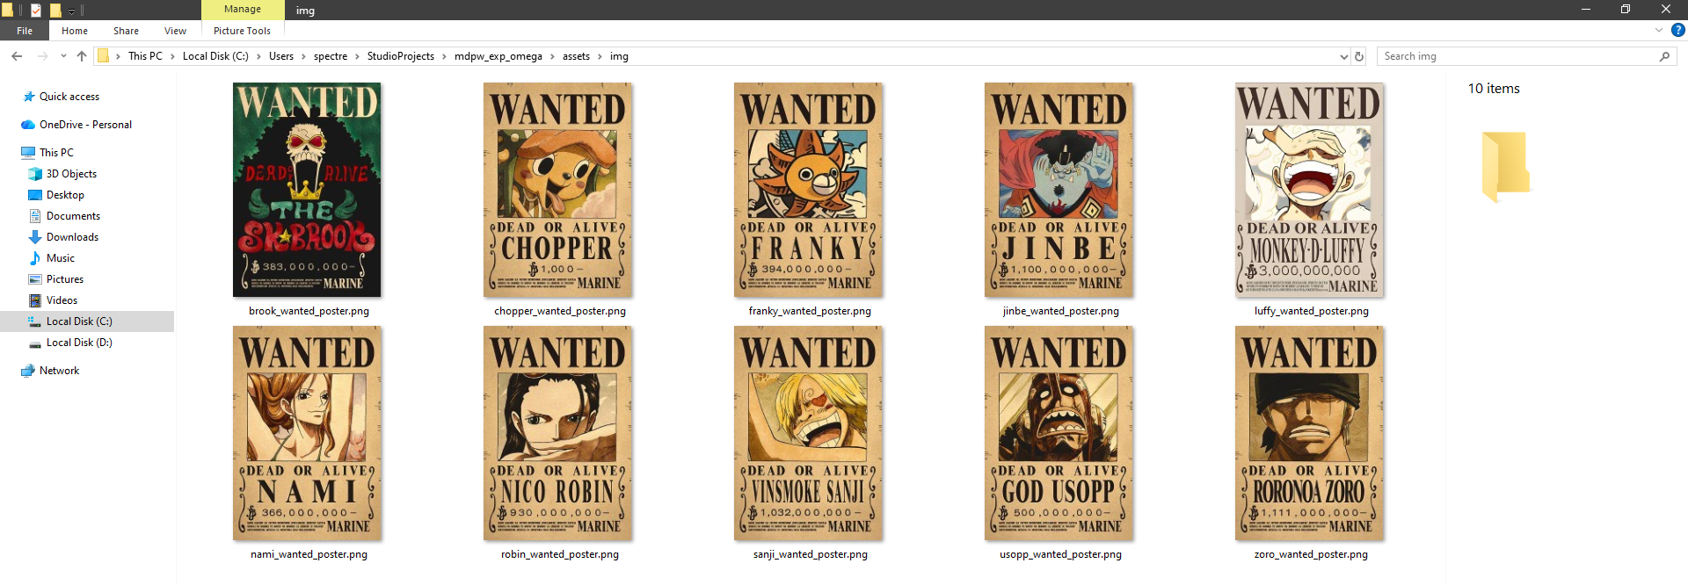

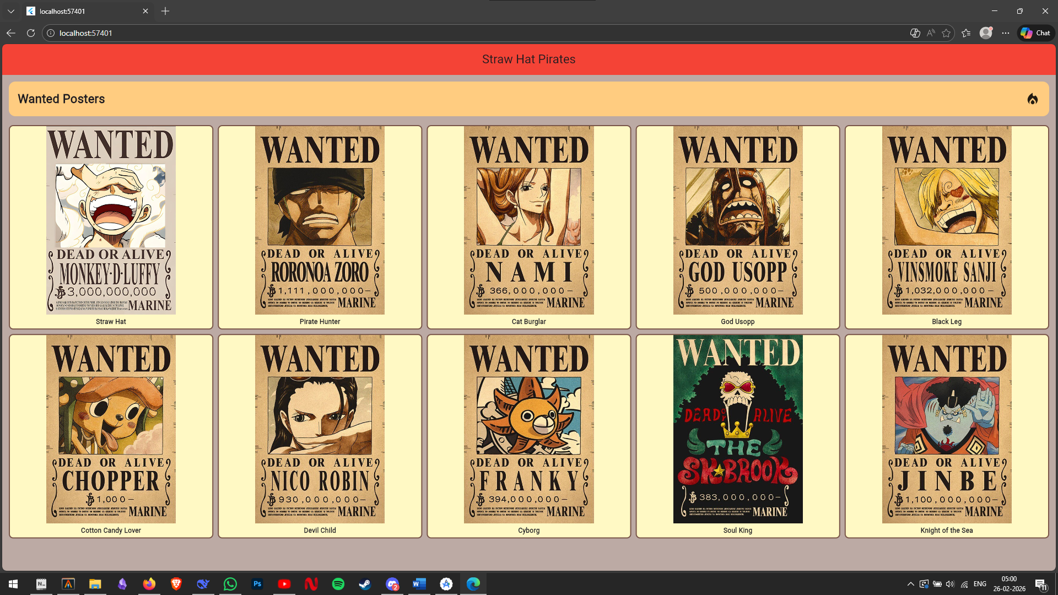

Conclusion
This experiment successfully demonstrated Flutter's core layout widgets—Row, Column, Container, Expanded, and Padding. These widgets were effectively combined to create a responsive, well-structured interface.

